Artificial Neural Network Basics
Code in Google Colab. Use for studying and understanding the context given in this document. The chapters are listed the same for ease of understanding.

https://colab.research.google.com/drive/1r0Tf8y352b88Vbj1xduyMNCQ_-abAWdL?usp=sharing

O’reilly Fundamentals for Deep Learning free chapter:
https://www.oreilly.com/library/view/deep-learning-for/9781119543046/c01.xhtml

O’reilly is usually where programmers go to understand new programming technology. This includes the whole field of artificial intelligence.

In this document we will explore the Artificial Neural Network (ANN) from scratch, at its core, at the foundation level.

ANN is inspired by the biological neural network, hence the name. The model of ANN learns directly from the given dataset, hence ANN is a type of supervised machine learning. ANN consists of nodes or neurons, connected by wires called weights. Biases are a type of changing neuron. Think of them as a fixed addition. The main purpose of an ANN is to capture the relationships in data. Patterns.

Before we dive deep into the jargon and mechanism of a true Artificial Neural Network, we can use Linear Regression to introduce the workflow of ANN and its core functions; the things that must exist in training an ANN model, the pipeline or workflow.

Commonly, ANN is used for either regression tasks or classification tasks.

Do note that architecture is often referred to as “Net” in the Neural Network and Deep Learning community. Deep learning being a neural network that has more than 2 hidden layers deep.

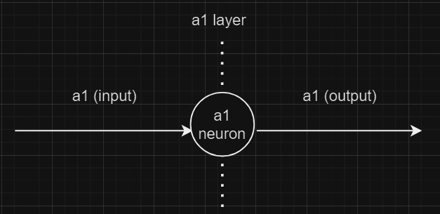
Figure 0.1. Layer representation
In the Neural network, each neuron is represented as in Figure 0.1. It is important that this is understood, and the interpretation of input and output becomes increasingly important with the complexity of models.

Important: See that the weights are multiplication, are the arrows
Bias are the addition, usually added at the output of a layer, represented as neurons.

Important: Input layer will not have calculations in this document unless specifically stated so, hence calculations always happen in hidden layer’s input and output. Therefore,
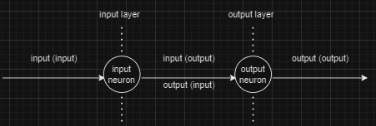
Is equal to
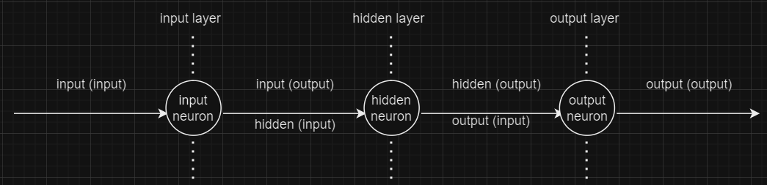
Or Input of input layer = Input of hidden 1 layer
But for simplicity’s sake and limited space, sometimes the input and hidden are mixed together

1. Linear Regression for y = 5x + 20 (1 in, 1 out)

Forward propagation
The neural network, being a network, can always be represented in a graphical manner. The linear regression algorithm can be represented as follows:
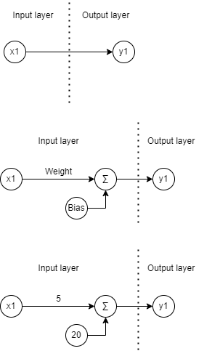

Figure 1.1 (a) Top,(b) Centre, (c) Bottom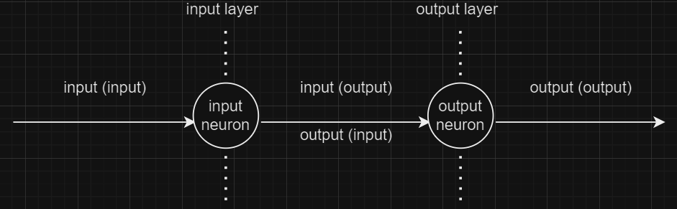
Figure 1.2. Full representation of Figure 1.1 (top)
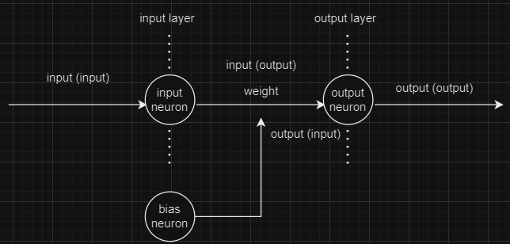
Figure 1.3. Full representation of Figure 1.1 (Centre)
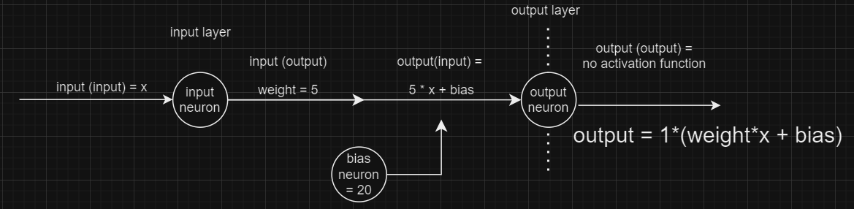
Figure 1.4. Full representation of Figure 1.1 (Bottom)
The network being a simple linear regression, requires no multiple neurons, no hidden layer. And the input layer itself can work as a hidden layer (in the sense that there is calculation occurring every time there is an arrow). The first figure on top shows that this model has 1 input layer, 0 hidden layer and 1 output layer. It has 1 neuron (x1), therefore it has 1 weight and 1 bias. Bias usually goes together with weight, but it is not necessary for bias to always occur.
Do understand that the whole architecture or structure of the model is entirely dependent on how you define it. There is no fixed architecture.

The second figure at the centre shows the actual representation of the model that we want to achieve, Y (output) = 5X + 20. Weight = 5, Bias = 20. You can think that weight is multiplied with its connected neuron. And bias is just an additive. Therefore in this model, there are 3 neurons, 1 input (x1) neuron, 1 bias neuron and 1 output neuron. The actual representation of the model is as shown,

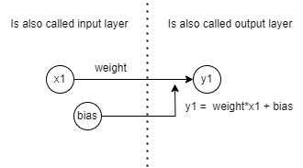
Figure 2. Simple representation of the model
Figure 1 and 2 shows the Forward Propagation part of the model, which is used to simply feed the input into the model and output as it is designed.

Note: Can try to think of it like a factory, input being raw material, the hidden layers being whatever processes that happens within the factory, processing the materials with its machine, and outputting whatever the result is as a product of the factory.

In this case, the weight is simply something that shapes the function. In some other cases when ANN is used to classify dog photos, weights can be seen as the strength of the connectivity between 1 neuron to another. Will be further discussed later but just know that the idea of weight is fluid and is only represented by the designer.

Back propagation of errors
Back propagation of errors or back propagation will occur while training a model, after the forward propagation. During back propagation, the first step is to calculate the difference between the desired output (from the dataset provided) and the actual output by the model during the forward propagation, and the output is called the error.

The error is then passed to a loss function to calculate the gradient of the loss with respect to the weights and biases of the network. Common loss functions such as mean squared error (MSE) and cross-entropy loss.

MSE is commonly used in regression problems (where the target variable is continuous and the goal is to minimise the difference between predicted and desired values) while CE is commonly used in classification problems (where the target variable has multiple classes or represents binary outcomes, such as identifying whether an object in a picture is a dog).

Example 1: Cross-entropy (CE)

On the other hand, cross-entropy (CE) or log loss measures the difference between the predicted probability distribution and the desired probability distribution of the target variable.

Multi-class CE’s formula is such that,
$CE = -\frac{1}{m}\sum_{i=1}^{m}{}y_{i}∙ log (\hat{y_{i}})$
Binary class CE’s formula (Only 2 classes, e.g., cat and dog) is such that,
$CE = -\frac{1}{m}\sum_{i=1}^{m}{}y_{i}∙ log (\hat{y_{i}})+(1-y_{i})∙log (1-\hat{y_{i}})$

Will not go into detail of CE yet but here’s some good resources:

READ THIS: https://medium.com/unpackai/cross-entropy-loss-in-ml-d9f22fc11fe0#:~:text=Cross-entropy%20can%20be%20calculated,*%20log(Q(x))

Other most common loss functions used are listed below:
https://builtin.com/machine-learning/common-loss-functions

Loss functions can be developed by oneself to best fit their purposes but the generalised loss functions are usually good enough for typical tasks such as object detection.

Do note that following this document, only regression tasks are explored yet.

Example 2: Mean Squared Error (MSE)

The following shows the formula of MSE,

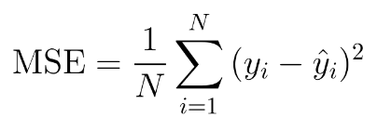
y_{i} = desired output by model

ŷ_{i} = actual output by model

First step is to get the error via the equation y_{i} - ŷ_{i}. Then, the error is squared to ensure the output is always a positive value, such that if the next epoch’s error is a negative, it will not overlap with a positive error, resulting in false alarm that there is no error occurring. Then the total of the errors are calculated, before divided by the total number of data; The mean of the squared error is calculated.

MSE is used on raw numerical values and aims to minimise the squared differences between predicted and desired value. It measures the averaged squared distance between predicted and desired values.

Due to its behaviour, MSE is sensitive to outliers as it squares the difference, thus if the data has an outlier with large deviation from desired values, it may significantly impact the loss.

MSE is only useful for convex functions, where there is no local minima/maxima and only 1 global minimum/maximum.

Gradient Descent
The goal of our regression is usually to find the global minimum. In the case of loss function of MSE, the goal is to reduce the loss gradually to near 0. Gradient descent graph can be summarised as below,
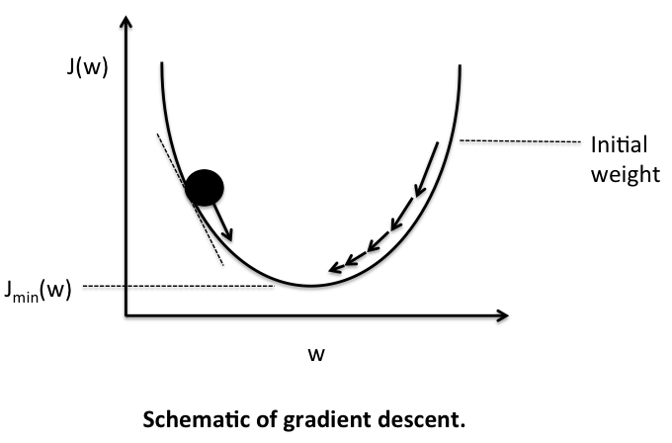
Image obtained from: https://medium.com/@23.sargam/gradient-descent-how-complex-problems-converge-7c1dc5ce739a

The ball is the weight and bias. The arrows can be compared with momentum and acceleration of classical physics, where the acceleration changes based on learning rate. The higher the learning rate, the further the jumps will be. If the learning rate is too high, you will likely always overshoot the global minimum/maximum and never achieve the desired lowest loss / highest accuracy / best fit function.

As the ball approaches the global minimum, the behaviour is called gradient descent, as it converges towards the minimum. However if it does not converge, the behaviour is called divergent w

2. Linear Regression Gradient Descent for y = 5x² + 10x + 20 (1 in, 1 out)
MSE derivative for the function:

Y = 5x² + 10x +20
(y - y_pred)² = (y² - y*y_pred + y_pred²)
= ((w1x² + w2x + b)² - (w1x² + w2x + b)*(y_pred) + y_pred²)
dloss/dw1 = 2x² * (w1x² + w2x + b) - x²y_pred = 2x²*y-x²*y_pred
dloss/dw2 = 2x * (w1x² + w2x + b) - xy_pred = 2x*y-x*y_pred
dloss/db = 2* (w1x² + w2x + b) - y_pred = 2*y-*y_pred

As observed, the differentiation function quickly becomes complex with an increasing number of weights and biases.

The y function is an example of a polynomial function, where polynomial regression should be done to obtain the function. Polynomial regression is the nonlinear version of linear regression, where it is used to regress nonlinear functions with power x², x³,… etc.

Polynomial regression method uses the activation function. We will explore more about activation functions in the next chapter.

In this chapter, the y function is still obtainable albeit under very tight circumstances; very low learning rate, very high epoch, must have good data to allow training. In other words, it requires a lot of fine-tuning in order to properly define the model as intended.

Let’s try linear regression, without using the activation function. The following graph is the architecture of the model. Similarly, it has 1 input neuron and 1 output neuron. It has 1 hidden layer with 3 neurons, with Weight3 acts similarly to a bias because of the simplicity of the model.
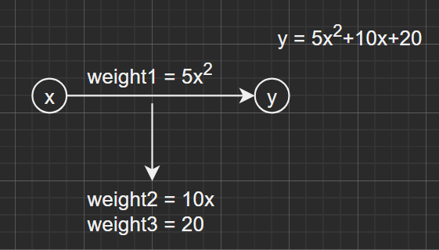
Figure 2.1. Simple representation of ann model
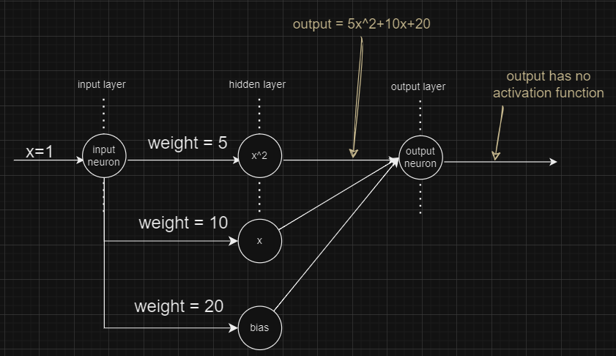
Figure 2.1. Understanding the codes
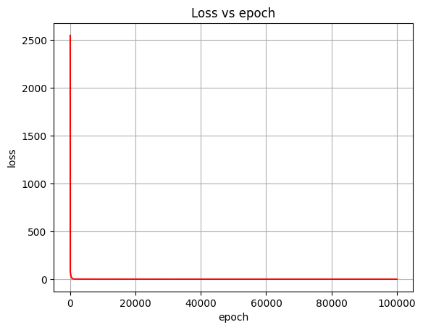
With LR = 0.001, Epochs = 100000
Weight1 : 4.997769103031339
Weight2 : 10.014393507156434
Weight3 : 19.980821751747754 Output predicted by model : [22.183611217300296, 39.1948814687006, 66.2016899261636, 103.20403658968927, 150.2019214592776] Actual output : [22.2, 39.2, 66.2, 103.20000000000002, 150.2]

Note: Activation function is not necessary since it will add complexity to the model which is not desired in this case.

Conventionally, weights of layers will be represented as a list form [5, 10, 20] or array (x, 1), x = 1,2,3,..., instead of what we see here with manually programmed having 3 weights. In other words, the conventional representation of the ann model shown above is,
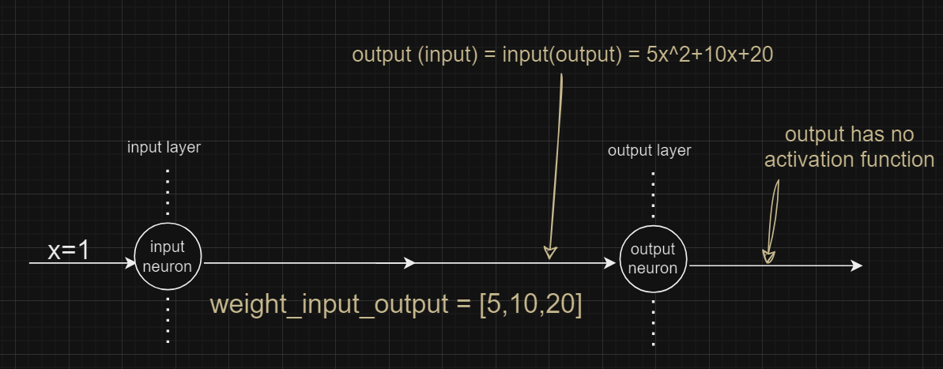
Figure 2.2. Full representation of the model, conventional way
Conventional ANN models (using Keras, Tensorflow, Pytorch libraries) always work with matrices.

3. Polynomial Regression Batch gradient descent for y = 5x⁵ + 10x³ + 20x² + 35 (1 in, 1 hidden, 1 out)
What happens if you use the similar way as as Chapter 1; linear regression, without activation function is the loss graph would look as below,
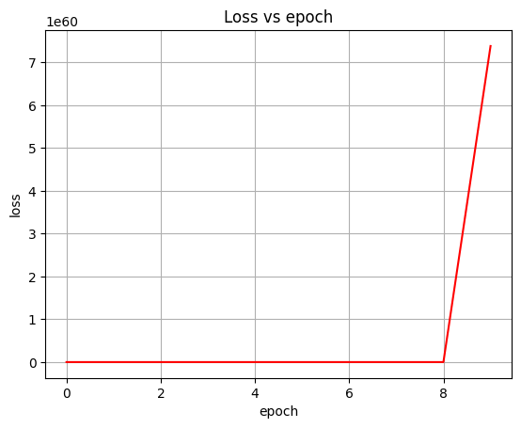
This is because the input does not have a linear relationship with the output; the function of y is not a linear function, hence it cannot be solved linearly.

Polynomial regression
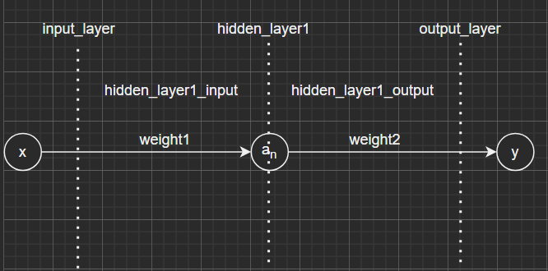
Figure 3.1. Simple representation of ann model
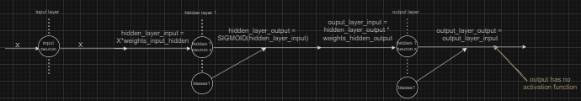
Figure 3.2. Full representation of the model
With complex polynomial equations, the ways shown above quickly become unreliable unless one decides to derive all those increasing powers on their own, moreover for the function to even fit in the linear methods anyway.
Let's introduce activation functions and generalised functions for doing the same task.

In this ann model, the forward propagation function reverts to a simple linear function of
y = mx+c
But the difference is, upon the output of the function, an activation function is introduced, such that the final output of the neuron becomes
y = ACTIVATION_FUNCTION(mx+c)

The loss function used in this model is the same MSE for y=mx+c.
lr = 0.001
Epoch = 10000
activation_function = sigmoid

Hidden layer size = 1
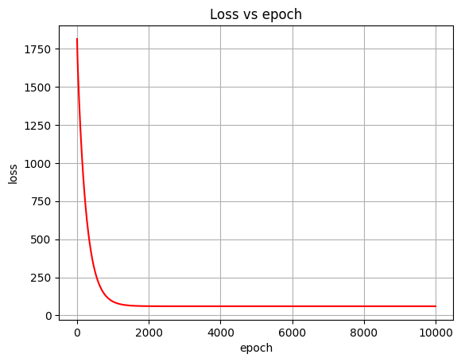
Weight1 : [[-30.56498064]] #weights_input_hidden
Biases1 : [[-29.07835449]] #biases_input_hidden
Weight2 : [[-0.69805585]] #weights_hidden_output
Biases2 : [[41.198105]] #biases_hidden_output
Predicted y for x = 0.5: 41.19810500309927
Actual y for x = 0.5: 41.40625

As observed, the weights and biases no longer are defining the function’s parameter, but the model is detecting such a pattern such that when the weights and biases are fit into the data, it will produce exactly the same result as if you directly plug in the data into the actual function itself.

Hidden layer neurons are defined purely by oneself, to increase complexity or to not.

Hidden layer neuron size = 10
In this setup with activation function and derivative of loss with respect to hidden layer is done, such that increasing the hidden layer size is simply a definition as such:

The result is such that the pattern is still recognised, but added extra resources for computation.

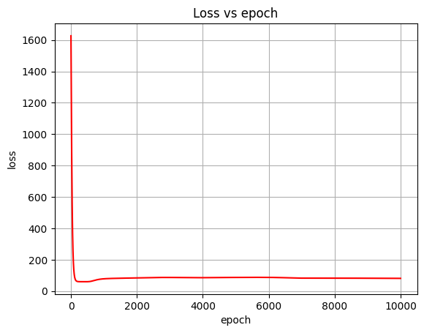
Weight1 : [[ 15.91846635 57.75533142 14.75578818 39.75605453 35.62741565 27.47990219 92.16036889 71.42974928 173.45532901 76.81608555]] #weights_input_hidden
Biases1 : [[ 12.01099286 51.59466183 12.53411677 35.031041 31.17425616 24.22372636 82.8169952 63.79983081 157.20164909 68.44797308]] #biases_input_hidden
Weight2 : [[ 1.79545329] [ 1.69418859] [-1.21137843] [ 3.16318428] [-0.52696978] [ 0.17323564] [ 3.74132723] [ 2.00919395] [ 9.06406516] [ 1.934626 ]] #weights_hidden_output
Biases2 : [[19.73842659]] #biases_hidden_output
Predicted y for x = 0.5: 41.575352510646304
Actual y for x = 0.5: 41.40625

Although the loss reduced much quicker.

It is important to see that biases2 only has 1 element as output only has 1 size. Biases are influencing the output of a layer, where its array size is equal to the output layer’s input.

4. What is the activation function and why is it widely used?
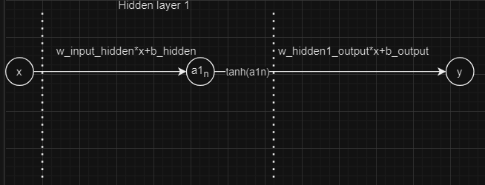
Activation function is used to introduce non-linearity into the network. Non-linearity refers to the property of a function or a system where output is not directly proportional to the input.

Activation function is always used before the output is passed as input for the next layer (it is usually the final step of the calculation)

A linear function is such that it has a constant rate of change and can be represented in a straight line.
Example: y = 2x is a linear function, where you can plot the points (0,0), (1,2), (2,4), (3,6),... in a straight line.

A nonlinear function does not have a constant rate of change and cannot be represented by straight lines. A function such as y = x² is a nonlinear function, albeit still can be derived and found by an ANN model.

In ANN, non-linearity is introduced through activation functions. Activation functions’ role is to transform the summed weighted input from the node, into the output value. It can be thought of as how likely is the neuron to be activated, and the behaviour of the transformed output is based on how the activation function is defined.

With activation function, the model is able to find non-linear patterns in the data. It is important to understand that the choice of activation function used has a significant impact on performance of the neural network. Different activation functions have different properties that may be suitable for the task. The activation function used in a single layer does not have to be the same for other layers.

Step function is such that the output will only show if the input is a positive value; remove negative outputs. Sigmoid activation function is such that it maps the output of the node to the spectrum between 0 and 1, where the behaviour is that of an S-shaped curve. The following table is illustrated to clearly show the difference between different activation functions.

Name | Graph | Explanation | Strength | Weakness
Linear function | 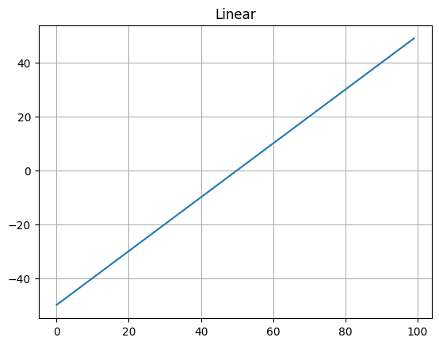 | ~ f(x) = ax+b, where a and b are constants | ~ Computationally efficient  ~ Works well with linear regression problems when the task is for the network to output linear combinations of its inputs | ~ Cannot capture complex, non-linear relationships in data
Binary Step function | 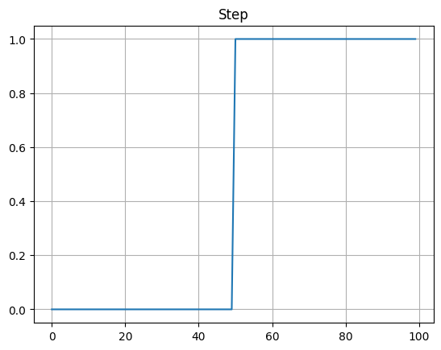 | ~ Returns 1 if output is more than 0, else return 0  ~ Is a simple “yes” and “no” representation | ~ Mainly used in binary classification | ~ Lack of differentiability, not suitable for most neural networks
Sigmoid/Logistic function | 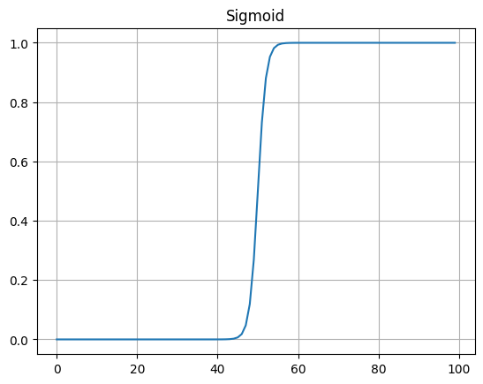 | ~ Maps to a range between 0 and 1 | ~ Smooth gradient, squashes to [0,1] | ~ Vanishing gradients, outputs non-zero centred
Tanh function | 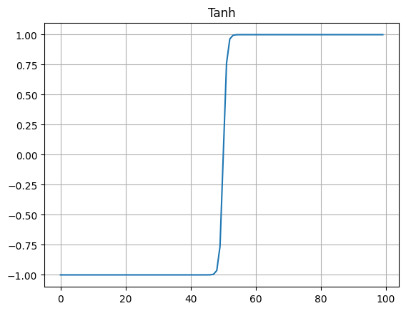 | ~ Smooth S-shaped curved centred at 0  ~ Slightly different representation than sigmoid | ~ Smooth gradient squashes to [-1, 1] | ~ Vanishing gradients, outputs non-zero centred
ReLU (Rectified Linear Unit) | 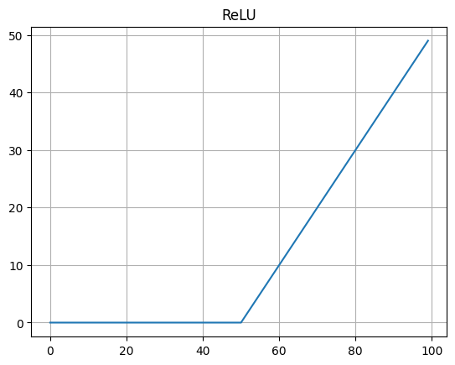 | ~ f(x) = max(0,x) | ~ Computationally efficient  ~ Mitigates vanishing gradient  ~ Promotes sparse activation | ~ Not zero-centred  ~ “Dying ReLU” problem  ~ Not suitable for all tasks
Leaky ReLU | 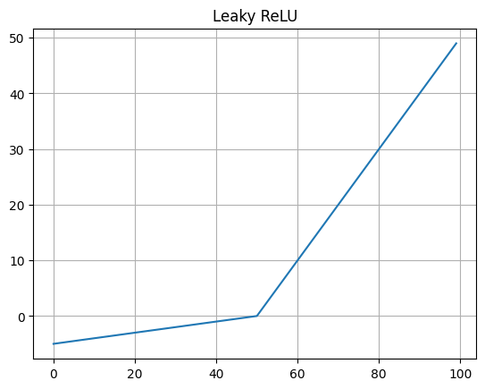 | ~ f(x) = x if x > 0  ~ else f(x) = a*x, where a is a small positive constant, e.g., 0.1) | ~ Addresses “Dying ReLU” problems;  ~ Mitigate vanishing gradient | ~ Not zero-centred  ~ Parameter ‘a’ must be tuned
Parametric ReLU (PReLU) | 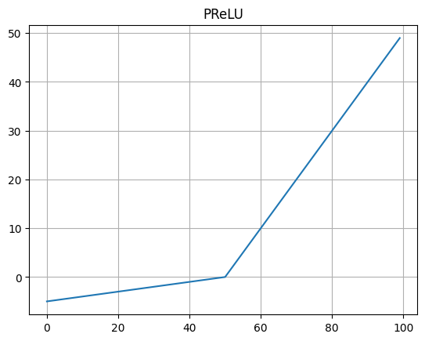 | ~ Basically ReLU but alpha is trained instead of tuned  ~ f(x) = x if x > 0  ~ else f(x) = a*x (a learned parameter) | ~ Addresses ‘dying ReLU’ problem  ~ Mitigate vanishing gradient | ~ Not zero-centred  ~ Requires learning ‘a’ per neuron
ELU (Exponential linear unit) | 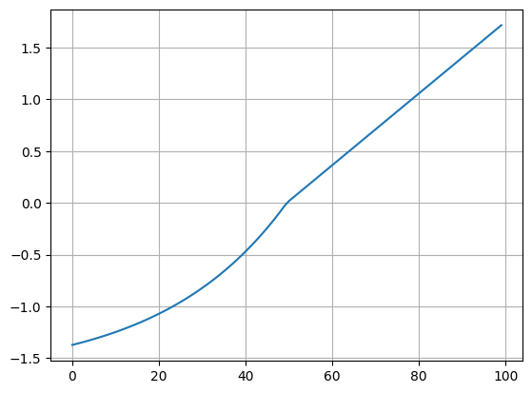 | ~ f(x) = x if x > 0  ~ else f(x) = alpha * (e^x - 1) | ~ Smooth gradient  ~ Address vanishing/exploding gradients  ~Trainable parameter ‘alpha’ | ~ Computationally more expensive than ReLU  ~ Not zero-centred
SeLU (Scaled exponential linear unit) | 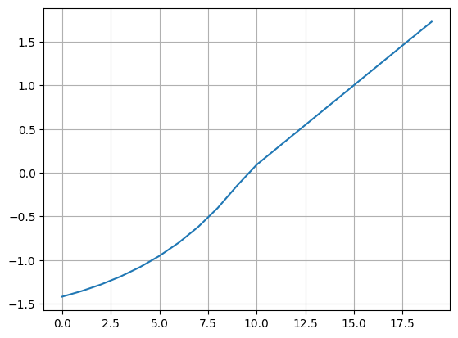 | ~ f(x) = scale*x if x>0  ~ else f(x) = scale*x*(a*(e^x-1))  ~ Scale is a constant multiplier applied to the output  ~ Scale is usually denoted as λ  ~ Scale is usually  λ = 1.0507  ~ a is usually  a = 1.6733  ~ The input data must be normalised to function properly | ~ Self-normalising property  ~ Smooth gradient  ~ Address vanishing/exploding gradients | ~ Complex formulation  ~ Requires specific initialisation  ~ LeCun initialisation or layer initialisation by Yann LeCun which is done to overcome vanishing and exploding gradient  ~ Must have Gaussian distribution with mean of 0 and standard deviation of 1
Some extra details: https://medium.com/@kshitijkhurana3010/activation-functions-in-neural-networks-ed88c56b611b

Sparse activation
Sparse activation refers to a situation where only a small subset of neurons or units in a particular layer becomes active; non-zero activations, while the majority remain inactive; activation becomes zero.

Vanishing Gradient / Exploding Gradients
Vanishing gradient is such that during training of deep NN, especially when using activation function that squashes their input into a small range, such as sigmoid and tanh.
The problem is when these activation function has derivatives that becomes very small as their inputs move away from zero, especially in the tails of their curves. Effectively removing the gradient, hence the name.
- During back propagation, gradients are computed to update the model’s weights. Gradients are calculated by taking the derivative of loss function with respect to model’s parameters.
- In deep networks, gradients are propagated backward layer by layer (based on chain rule of calculus)
- When gradients are small due to the activation functions, updates to the weights become very small (lower layers of the network learn very slowly as the weight hardly change @ w -= learning_rate * gradient_of_w, remember that gradient of weight is the derivative of the weight.
- As a result, the network may fail to capture any meaningful features, where sometimes the network doesn’t learn anything at all as the gradient “vanishes”, becoming 0 @ w -= 0.

To mitigate Vanishing gradient, activation functions that have gradients that do not become small for positive inputs are introduced (such as RELU and its variants)

Exploding Gradient on the other hand is when the activation is too high, allowing that particular neuron to always activate, resulting in the same “not able to learn meaningful pattern” issue.

Dying ReLU
“Not zero-centred” can lead to vanishing problem

Dying ReLU refers to the specific issue where ReLU neurons activate for positive inputs but output zero for negative inputs, refer to the graph in the table.
Problem arises when the neuron keeps outputting zero for all negative inputs and never activates.

To address this issue, several variants are introduced. Examples such as Leaky ReLU where it allows a small gradient for negative inputs. Another is Parametric ReLU (PReLU), where slope for negative input is learnt during training.

Final note
One can always start with ReLU, and observe the output. SeLU has even better performance, however it has higher resource requirements.

5. Trigonometric function gradient descent for y = cos (x) (1 in, 1 hidden, 1 out)
- The task at hand is to fit a bunch of data (raw number and desired output of y=cos(x)) into the model.
- The activation function chosen is tanh and loss function MSE (or MAE; mean absolute error).
- This model has 1 input layer, 1 hidden layer and 1 output layer.

The full architecture representation is shown as below, with n being the number of hidden neurons to be set manually by the user.

Figure 5.1. 1 Hidden layer with tanh activation function

For multiple hidden layers, the architecture would look as below,

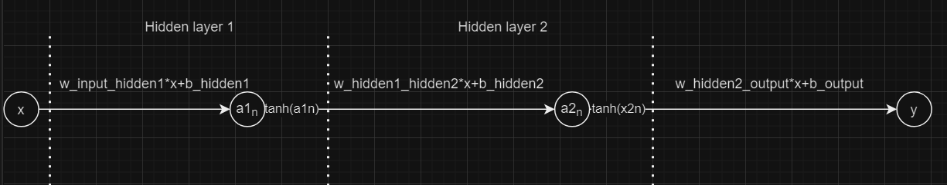
Figure 5.1. 2 Hidden layers with tanh activation function
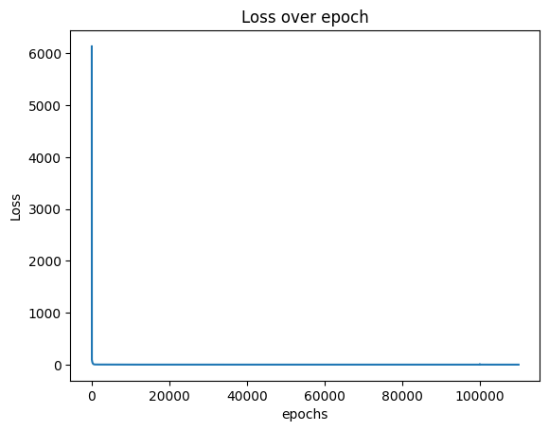
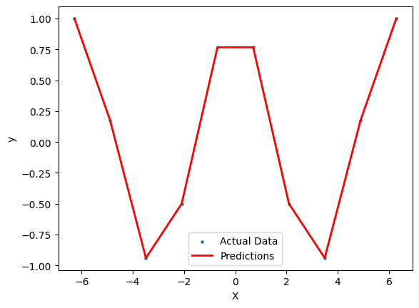
With 10 data to work with from -pi to pi, and 10000 epochs with 0.01 learning_rate, using tanh activation function and MSE loss function, the predicted output is as such.

Why hidden layers?
Before we continue with Chapter 6, I would like to provide examples to the effect of increasing hidden layers. Hidden layers are used to allow the model to learn complex patterns, but increasing hidden layers alone will not learn everything if the structure provided is not sufficiently complex for complex tasks. Both the number of neurons and the number of hidden layers can be used to improve accuracy and learn complex patterns. These are trained on SGD optimizer

Example 1: 0 Hidden layer (Under fit)
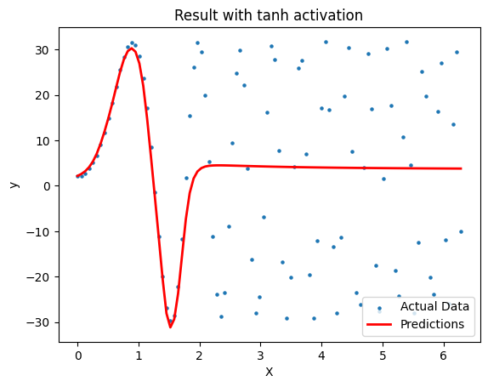
Example 2: 1 Hidden layer
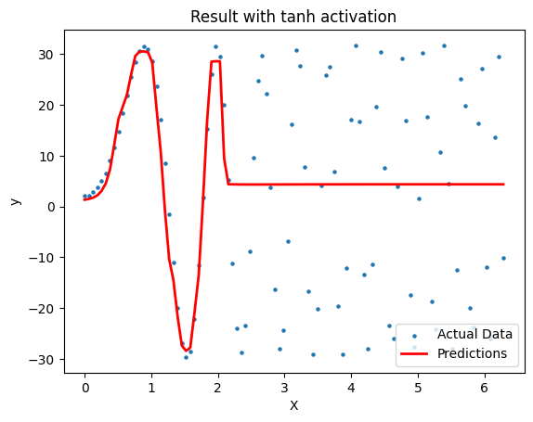

Example 3: 2 Hidden layers (Vanishing gradient)
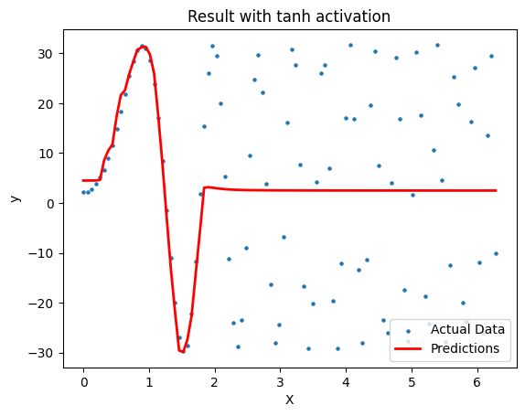
Example 4: 3 Hidden layers (Vanishing gradient)
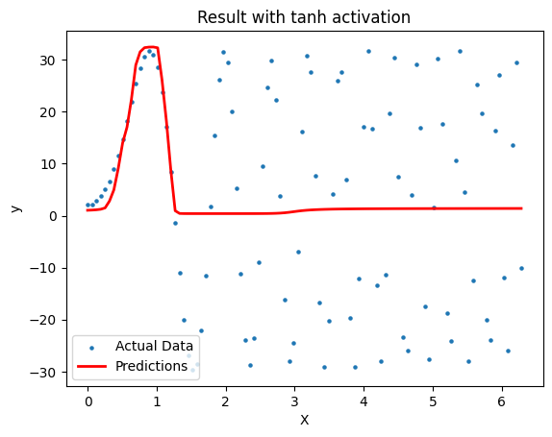
As you observed, in this context increasing hidden layers causes the model to work worse. This may be due to gradient vanishing, incorrect architecture, lack of regularisation, parameter settings etc. This is to show that increasing hidden layers may not improve performance. In fact increasing more may have detrimental returns.

What is underfitting and overfitting?
Underfitting means the model is not generalised enough, and it could not provide results as desired. A simple example such as the desired function is y=2x^{2.}+ 30. But the model provided function post-training is y=x²+10. This means there is either not enough data, not enough epochs, architecture is not good enough, etc. Be careful that increasing the number of neurons and hidden layers may lead to overfitting issues instead. Therefore, balancing via fine tuning or hyperparameter tuning is crucial to create a good generalised model.

On the other hand, overfitting means the model fits too well into the data. If using gradient descent task examples, overfitting is such that the function fits exactly into the data, where any new data fitted into the model, will not produce the desired result. The simplest example of overfitting is imagine you train a model to detect a cat but you trained it with only 1 picture data. The model will only know that in this particular pose, pixel location, pixel metadata, in which that picture has a cat. If you use the same model to detect a completely new picture with a cat, the model will not tell you that there is a cat. In that case it is because of the lack of data, the model has overfit into the training data.

6. Effect of Hidden layers, Activation functions; Trigonometric and Polynomial function for y = 2 cos² (3x) + 30 sin(2x²)
In this chapter, the codes will show the usual version without using Keras or other AI framework libraries, followed by versions with AI framework. This is because they are equivalent but using the framework quickens the process of creating models, moreover easier to customise to our needs. Future chapters will begin to use keras framework, but understand that they function the same, and understand the underlying workflow is important.

Keras library is a derivative of Tensorflow which is a platform developed by Google Inc. To improve the workflow or pipeline of deploying Neural Network models. With Keras being more lightweight to favour smaller dataset and faster deployments compared to Tensorflow, Tensorflow is used mostly by large models for scalability and mass deployability.

This function is a polynomial as well as a trigonometric function. Due to the complexity of the function, I have decided to start with 2 hidden layers with 64 neurons within each hidden layer.

The model follows the same 1 input neuron, 2 hidden layers, both with 64 neurons, and 1 output neuron


Figure 6.1. Architecture of model

Using Tanh activation function
Refer to the link of Google Colab to understand more.
The difference between these functions are only the activation functions. The structures all follow the figure as above. Figure below shows the loss with tanh activation and the results with plot. As shown, the structure is very simple with 1 hidden layer, 3 weights and biases, from input-hidden1, hidden1-hidden2 and hidden3-output. The loss is calculated with MAE or mean average loss which instead of squaring the error, the absolute value of the loss is taken.

- Gradient Descent Optimiser, tanh activation function, mae loss function, 1 hidden layer of 64 neurons
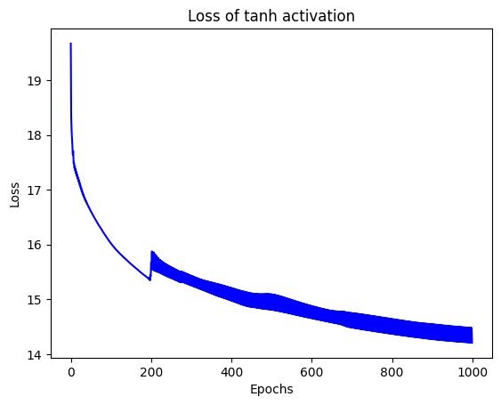
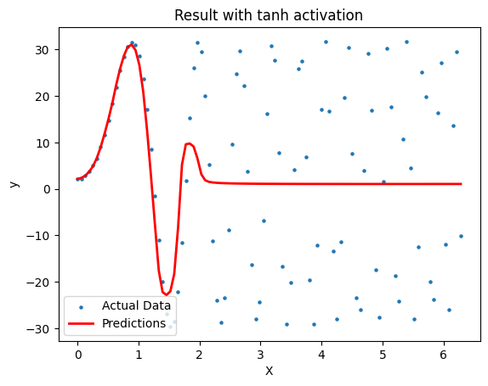

- Stochastic Gradient Descent Optimiser, tanh activation function, mae loss function, 1 hidden layer of 64 neurons


- Using ReLU activation function with SGD optimiser
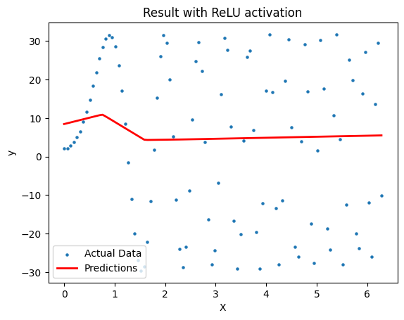

- Using Relu activation function with Adam optimiser
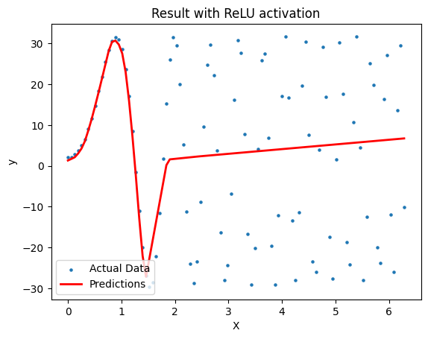

- Using Leaky ReLU activation function with SGD optimiser
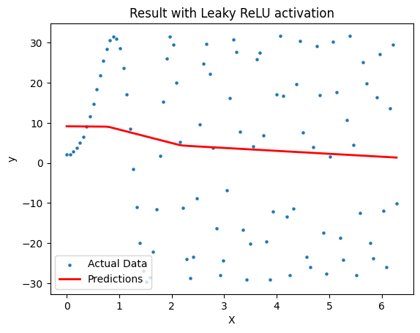

- Using Leaky ReLU activation function with Adam optimiser
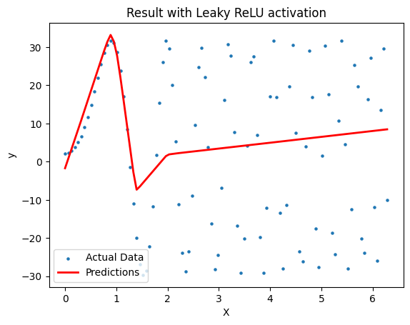

Training a model. What is an Optimizer algorithm? Gradient Descent, Stochastic Gradient Descent, RMSProp, Adagrad, Adam
So far above this chapter all used Gradient Descent algorithm to train the model. Gradient Descent describes the desired behaviour of the model as the model converges towards its target. However it is hard to determine whether the model is converging towards its target, hence ‘loss’ is used instead to find out how far is the model compared to the desired value. As mentioned in Chapter 1, gradient descent describes the behaviour of a model as it converges towards the global minimum as shown in the graph. However, when the function becomes more complex, the emergence of local minima/maxima will occur.

Local minima/maxima describes the local minimum near a weight / parameter, that is not globally minimum/maximum. If the model falls into the local minima, it may not converge towards what is desired, hence it prematurely converges. In order to combat such occasions, different training algorithms have been developed, namely Stochastic Gradient Descent, eventually more complex algorithms are developed, and the whole technique is called optimizer.

Gradient Descent
- is an optimization algorithm that iteratively updates the model's parameters in the direction of the steepest descent of the cost function, aiming to minimise the error between predicted and actual values.
- Each epochs train the entire dataset before updating the weights and biases
- Ie. Each ‘update weight and bias’ step only occurs after the model has run the entire dataset

Stochastic Gradient Descent
- is an optimization algorithm that iteratively updates the weights and bias the starts from a random point on a function, then travels down in its slope in steps
- During training, the updating weights and bias step occurs at every data point instead of the whole dataset.
- Converges much faster than gradient descent, especially for large dataset
- Less memory intensive
- Can be used for avoiding getting stuck at local minimums/maximums

Figure below shows the example of behaviour of BGD, MBGD, SGD, with Gradient descent being a straight line similar to that of BGD but do not have many breaks.
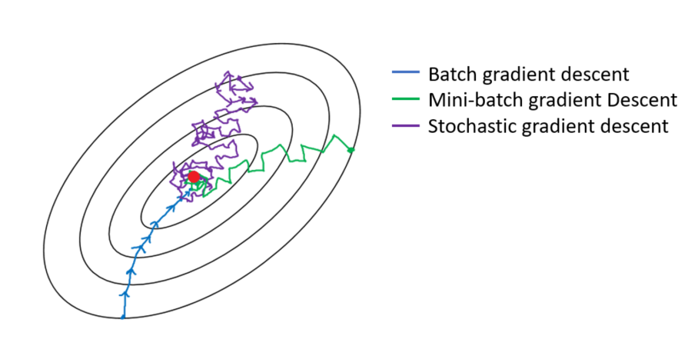
Figure obtained from: https://sweta-nit.medium.com/batch-mini-batch-and-stochastic-gradient-descent-e9bc4cacd461

TODO: Graphs of Optimizer

Optimizer | Explanation | Strengths | Differences
RMSProp | RMSProp (Root Mean Square Propagation) is an adaptive learning rate optimization algorithm for neural networks. | - Helps mitigate the problem of diminishing learning rates by adapting the learning rate for each weight individually based on the average of recent squared gradients. | - Maintains a moving average of squared gradients to scale the learning rates  - Divides the learning rate by the square root of the average of past squared gradients  - Provides faster convergence and better performance in non-convex optimization problems.
Adagrad | Adagrad (Adaptive Gradient) is an optimization algorithm that adapts the learning rate for each parameter. | - Automatically adapts the learning rate for each parameter based on their historical gradients.  Provides larger updates for infrequent parameters and smaller updates for frequent parameters  - Well-suited for sparse data problems or when dealing with features that have different frequencies in the dataset. | - Accumulates the squared gradients of each parameter.  - Divides the learning rate by the square root of the sum of squared gradients.  - Can have diminishing learning rates over time, which can slow down convergence in some cases.  - May require tuning of the initial learning rate to prevent learning rates from becoming too small.
Adam | Adam (Adaptive Moment Estimation) is an optimization algorithm that combines the benefits of RMSProp and Adagrad. | - Combines the ideas of adaptive learning rates from RMSProp and momentum-based updates.  - Maintains a separate adaptive learning rate for each parameter.  - Computes adaptive learning rates based on both the first and second moments of the gradients. | - Calculates exponential moving averages of both the gradient and its squared gradient.  - Uses bias correction to address bias towards zero initialization.  - Provides better convergence properties and generalisation performance compared to RMSProp and Adagrad.

7. Data structure and Architecture. AND Logic Gates (2 inputs, 1 output)
In this chapter we explore something that is not a gradient descent task. In this logic gates task, unlike in the regression task, we want the model to overfit and behave exactly as a logic gate would. We will train ANN models to fit into the behaviours of AND gates, XOR gates and NAND gates.

Proper AND gate architecture and data structure
We will have 2 inputs, and 1 output. We have very limited data as we only have 2 input data in this case. The data will look as below.

Input 1 | Input 2 | Output
0 | 0 | 0
0 | 1 | 0
1 | 0 | 0
1 | 1 | 1

The input of the architecture will be represented as

[0,0]
[0,1]
[1,0]
[1,1]
Where each column represents 1 data point, 2 elements in the array representing 2 neurons in the input layer.

While the output will be represented as

[0,0,0,1]
Where 1 row means 1 neuron and each element means the output of each row from input. Remember the calculation of matrix to understand why the output is represented as shown (or take Keras classes to understand the data structure representation of Keras library)

The importance of architecture design and data structure is shown.

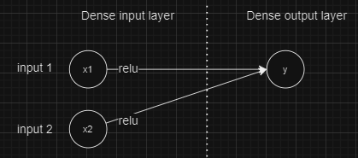
Figure 7.1. Horizontal graph of proper AND gate model
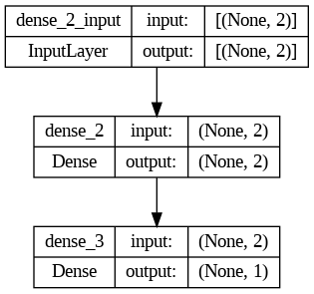
Figure 7.2. Keras generated graph of proper AND gate model

Reminder: Dense input layer is actually hidden layer, output of input layer = input of hidden layer

The middle (hidden) dense layer is used to connect the 2 input neurons to 1 output neuron. Hence Figure 7.1. representation does not draw the middle dense layer, and directly connects the output of Input layer to the input of Output layer.

Dense means fully connected. The inputs are represented as a 2D array [0, 0], [0, 1], [1, 0], [1, 1] because of how Keras Sequential model works. Output is represented in a Dense 1 unit layer where the representation is [0,0,0,1]. However, self-written versions can be represented in either 2D matrix form or 1D form. Relu and sigmoid activation functions are chosen randomly and the optimizer used was Adam to reduce the number of epochs needed to train the model. The result of training this model is as shown:
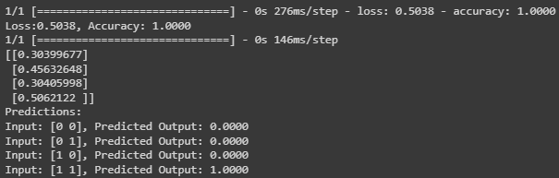
Figure 7.3. Result of proper AND gate model

Improper AND gate architecture
Another example, using the same 2 inputs but 2 outputs (wrong architecture):
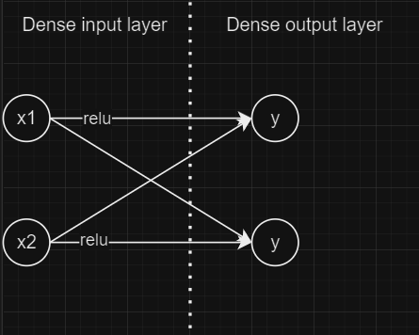
Figure 7.4. Horizontal graph of improper AND gate model
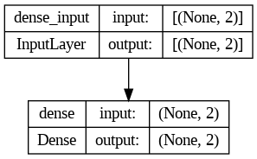
Figure 7.5. Keras generated graph of proper AND gate model
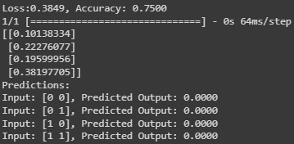
Figure 7.6. Result of improper AND gate architecture model

Improper AND gate data structure (Conventional modelling of neural network using Keras)
The architecture of this model is similar to that of Figure 7.1 and Figure 7.2.
The difference here lies in the representation of the desired output or label, [[0],[0],[0],[1]] or

0
0
0
1
While data structure that produces better result is a vector of length 4 (or flat array or 1D array)

[0,0,0,1]

This is because of how Keras calculates its matrix.

You can still work with it if you don’t use Keras libraries, and program all the matrix calculations yourself.

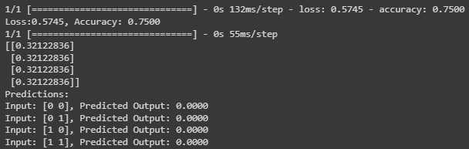
Figure 7.7. Result of improper AND gate data structure model

8. Full Adder behaviour with ANN model (3 inputs, 2 outputs)

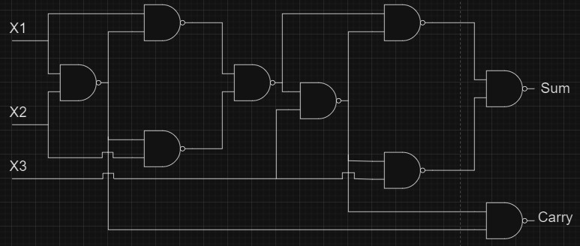
Figure 8.1. Full Adder diagram

The truth table of a full adder is as shown:
Table 8.1. Full Adder Time Table

X1 | X2 | X3 | Sum | Carry
0 | 0 | 0 | 0 | 0
0 | 0 | 1 | 1 | 0
0 | 1 | 0 | 1 | 0
0 | 1 | 1 | 0 | 1
1 | 0 | 0 | 1 | 0
1 | 0 | 1 | 0 | 1
1 | 1 | 0 | 0 | 1
1 | 1 | 1 | 1 | 1

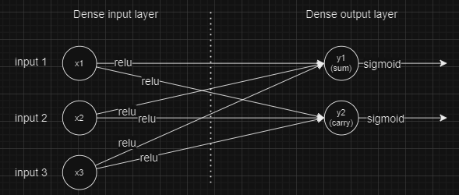
Figure 8.2. Architecture of model
Reminder: Dense input layer is actually hidden layer, output of input layer = input of hidden layer

The architecture of the model is such that it has 1 input layer with 3 neurons, 1 hidden layer (relu activation) with 3 neurons, and 2 output (sigmoid activation) neurons with adam optimizer. Note that the representation of input data in this case is in the form of matrix instead of integer.

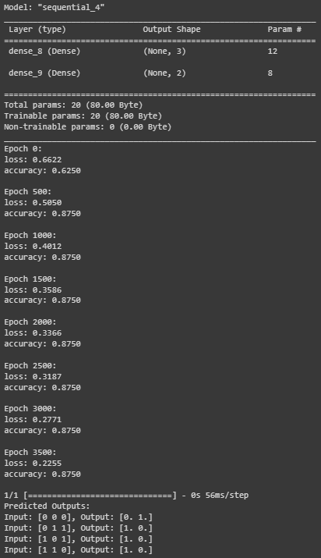
Figure 8.2. Result of model

Finally
Finally you can go through this video:
Neural Network from Scratch | Mathematics & Python Code by The Independent Code
https://www.youtube.com/watch?v=pauPCy_s0Ok

